Guide for Selecting
& Recording Videos

1. Purpose
This document provides a brief overview of the protocol that the videographer, or person responsible for recording the classroom footage, should follow.

2. Required Materials
- Video camera/iPhone (with ample storage)
- Rechargeable battery or power source
- Tripod
- Notebook to track teacher name, school name, grade, subject, and video length
- Phone, watch, or stopwatch to note the duration of the recording

3. General Steps for Arriving at the School
A day before the classroom observation is scheduled to take place, the team should contact the school authorities to ensure the appropriate approvals have been processed and to remind the school authorities of the scheduled visit. On the day of the observation, the videographer should arrive at least one hour before class begins. When s/he arrives, they check-in with the school officials and ask which classrooms they will be recording. S/he should never go directly to the teacher's classroom without first checking in at the main office.

4. Classroom Recording Protocol
It is important that videographers introduce themselves to the teacher before the formal instruction begins so that s/he has a general sense of the purpose of the observation. It is recommended the videographer briefly explain that the video recording will remain confidential and will not be used for evaluative purposes, but for a study of teacher practices and for training purposes in the given country. To make the class as natural as possible, the videographer should not be introduced to the students, and his/her presence should be as inconspicuous as possible. Videographers should not intervene in the class in any way. Before recording, the videographer must present the Recording Authorization Form for the teacher to sign.
Here is a sample introduction text that can be used to explain the purpose of the visit as the teacher is provided with the Recording Authorization Form:
“Good morning/afternoon, [Mr./Ms. XXX], I work for [affiliate organization]. Your classroom has randomly been selected to be recorded. We are requesting consent to record your lesson and use this video as part of a classroom observation training. The recordings will not be used for evaluative purposes, but rather as examples during a classroom observation training. These recordings are crucial to the success of the study. Please proceed with your lesson as you normally would.”

5. Recording Lessons

5.1 Choose the Schools/Teachers to Record
At least a week should be devoted to sourcing the videos, as a minimum of 15 full-length lessons (60 minutes) will be needed for the training/reliability materials. As the videos are being sourced, it’s crucial to ensure the recorded schools/teachers reflect of the diversity of the sample. Classrooms with different teachers, from different schools, and with diverse student populations (socioeconomic, proportion of girls to boys, etc.) should be prioritized.

5.2 Videotape in Real-Time
It is important to record the sampled teachers for at least 1.5 hours (or the equivalent of two full lessons). The first 15 minutes of this footage should be disregarded to ameliorate potential Hawthorne Effects. The camera should be turned on at the beginning of lesson 1 and not turned off until lesson 2 has concluded. It is important that the recording not be altered or interrupted, as to capture the nature of the lesson as accurately as possible. As such, be sure to record in a continuous stream and do not pause the recording. Begin the recording by pointing to a notepad with the date, time, grade level, name of school, and name of teacher written down. The videographer should be present throughout the duration of the lesson and should not leave the camera unattended.
5.3 Camera Placement
If possible, the videographer should position the video camera with the windows behind it, thereby avoiding backlight problems, and near the corner at the back of the classroom to provide a general view of the entire classroom and to get a side and back view of the students. Positioning the camera too close to the front of the room results in oblique angles that make it difficult to see what the teacher is doing, how s/he interacts with students, and what is written on the board. The camera should be positioned on a tripod and should not move during the lesson. The camera should be positioned to record what the teacher writes on the chalkboard, the actions of the teacher, and the actions of as many of the students as possible. It’s recommended the quality of the recording be tested for sound and image before the actual recording begins (see Annex 1).

6. General Guidelines

6.1 During Class, the videographer should:
- Sit toward the back of the classroom to get a view of the entire classroom.
- Ensure his/her presence does not hinder the students’ view of the classroom.
- Keep his/her personal belongings (backpack, purse, books) out of sight and only take out the materials needed for the recording.
- Not text or use cellphone during the lesson (cellphones should be put on Airplane mode during the recording).
- Not engage with students in any way; use nonverbal cues to redirect them from conversation when possible.
- Not disturb the class in any way, i.e. do not wave to students, take photos with the teacher, speak loudly to another videographer, text, make phone calls, etc.
- Avoid making the teacher and students feel uncomfortable with verbal remarks or nonverbal cues.
- Constantly ensure the video camera is recording properly.

6.2 After Class, the videographer should:
- Thank the teacher for allowing him/her to conduct the recording.
- Reassure the teacher that the recording is confidential and will not be used for evaluative purposes.
- Not comment on the classroom activities or the students’ behavior to anyone.

6.3 Organize the Files
Save the files with a name that can easily identify the teacher, school, grade level, and subject matter. If there are multiple videos with the same teachers or subjects, differentiate the names by using the date and time of the recording. Save the file and prepare a spreadsheet that includes the video file name, classrooms observed, date, subject, grade, teacher, and school (see Annex 2).
6.4 Send Files
All video files and Recording Authorization Forms should be sent to the Teach team: teach@worldbank.org.

Annex 1: Guidance on Angles and Camera Shots
Acceptable Angles and Camera Shots
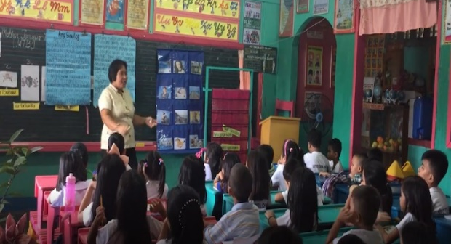 | This angle provides a clear view of the teacher and most students. The lighting is such that it’s easy to see what the teacher is doing and how the students are reacting to her instruction.
Unacceptable Angles and Camera Shots
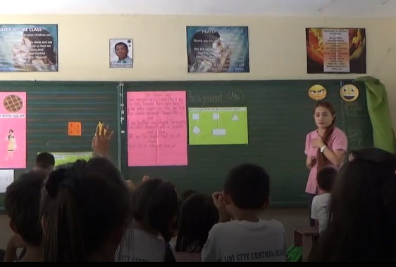  j | Although the teacher’s face can clearly be seen, it is difficult to see what the student is doing at the board and whether the other students are following along.
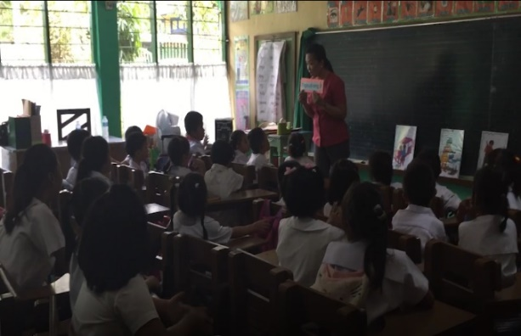 | This shot is a little too dark to properly see what’s going on. By positioning the camera at the other side of the classroom (with the windows to the back of the videographers), some of the backlight may have been mitigated.

Annex 2: Sample Video Inventory Spreadsheet
# | File Name | Subject | Grade | Video Length | Audio Quality | Image Quality | Positioning Quality | Segment 1 | Segment 2 | Comments | School ID | Dept. | Location | Rural/  Urban | Soc-econ Context
1 | 1_G6_MT | Spanish | 6 | 1:12:38 | Good | Good | Good | 01:28-16:50 | 34:05-49:43 | Some students do not appear on the camera | 10 | Cerro Largo | Melo | Rural | 3
2 | 2_G6_Math | Math | 6 | 44:29:00 | Good | Good | Good | 03:57-19:15 | 22:00-37:00 | Low attendance: 10 students. It is difficult to hear students' responses/comments | 10 | Cerro Largo | Melo | Urban | 3
3 | 3_G3_MT | Spanish | 3 | 38:02:00 | Good | Good | Regular | 0:00-15:13 | 25:00-38:00 | No view of the board | 24 | Rivera | Vichadero | Rural | 2
4 | 4_G6_MT | Spanish | 6 | 37:13:00 | Good | Good | Very good | 0:00-15:01 | 19:40-34:50 | It could be useful for Sciences | 24 | Rivera | Vichadero | Rural | 2
5 | 5_G6_Math | Math | 6 | 49:49:00 | Good | Good | Very good | 0:00-15:00 | 15:00-30:00 |  | 24 | Rivera | Vichadero | Urban | 2
6 | 6_G3_Math | Math | 3 | 50:29:00 | Regular | Good | Good | 0:00-0:15 | 34:00-49:00 | Segment 1: minute 12:15, when the teacher walks around the groups, it is not possible to hear what they are talking. Segment 2: most of the time it is not possible to hear the dialogues between the teacher and the students. | 375 | Montevideo | Santa Catalina | Urban | 2
7 | 7_G3_MT | Spanish | 3 | 45:24:00 | Regular | Regular | Bad | 0:00-0:15 | 19:40-34:43 | Difficult to see the board or teacher. We only observe 9 students. A lot of the time, it is not possible to hear what the students say | 5 | Cerro Largo | Rio Branco | Rural | 1
8 | 8_G6_Math | Math | 6 | 37:59:00 | Good | Good | Very good | 0:38-15:00 | 17:47-33:25 | Impossible to hear what the students say. | 5 | Cerro Largo | Rio Branco | Urban | 1
9 | 9_G6_MT | Spanish | 6 | 1:05:25 | Good | Good | Good | 0:00-15:00 | 15:00-30:00 |  | 86 | Rivera | Rivera | Urban | 1
10 | 10_G3_Math | Math | 3 | 30:55:00 | Regular | Good | Very good | 0:00-15:00 | 15:00-30:55 | The second segment will not be selected since the students are working in a group activity and it is not possible to hear the interactions between the teacher and them. | 86 | Rivera | Rivera | Rural | 1

The Teach team would like to thank Andrew Ragatz, Alonso Sanchez, and Viticia Thames for providing past recording guides from Vietnam, Nicaragua, and Afghanistan, which informed the Guide for Selecting & Recording Videos.

